BSI.IT.10.C11 – Vendor Defaults – CPA (2026)
IT RCSA – Configuration Management
Item | Detail
Control | BSI.IT.10.C11 – Vendor Defaults (Heracles 50539549)
Risk | [BSI.IT.10.R3 PW Config] Unauthorized access to systems and data due to failure to enforce strong password configurations may result in data compromise, system and business disruptions, financial loss, and regulatory noncompliance. (High)
Owner / executor | Ian Rojo
Relevance / nature / frequency | Key Control / Hybrid / In every operation
Testing period | 07/01/2025 – 06/30/2026
Prepared by / reviewer | Edward Morfa (IT RCSA) / Amanda Munoz Henry (Testing Manager)
Evidence | Folder BSI.IT.10.C11 Vendor Defaults/Evidence – files start with their E-number. Screenshots in Evidence/Screenshots.

Control statement
[BSI.IT.10.C11 Vendor Defaults] In every operation, Infrastructure teams change vendor default passwords for root or administrator accounts on Operating Systems before the server reaches install status in CMDB.
Status today
Not concluded – evidence pending

Test script
There is no BSI test script for this control in the 2026 Test Plan. This one follows the SBNA / C10 scripts and the C7 / C8 format, adjusted for BSI. It is also in the testing workbook, tab 2_Test Script.
1. Obtain Evidence
Obtain the CMDB list of servers that moved to Installed during the period (with install date), build records, evidence that the built-in Administrator (Windows) and root (Linux) default passwords were changed during the build, the Secure Build and Configuration Management Standard, the hardening guides and approved SEF exceptions.
2. Validate Report Completeness and Accuracy
Check the CMDB report source, filters and run date, and trace a few CIs to vCenter / Active Directory. Check that every configuration export or screenshot shows the server name and date.
3. Validate Population and Scope
Confirm the population holds every Windows and Linux server that reached Installed in the period. Select the sample with the RCSA sample size calculator.
4. Verify Control Execution
For each sample, check the built-in Administrator / root default password was changed (and, for Windows, Administrator renamed and Guest disabled), and that it happened before the CMDB install date.
5. Validate Control Results
Compare the configuration to SUS.SBS.4.2.3.4 and the Windows / Linux hardening guides. Record any default that was not changed.
6. Verify Exception Handling
For any default that could not be changed, check there is a CISO-approved SEF exception.
7. Verify Escalation and Remediation
For deviations, check they were escalated by InfoSec, tracked and fixed.
8. Assess Risk Mitigation
Decide whether changing defaults before go-live keeps default credentials off live servers.
9. Summarize Testing Coverage
Record population, sample, attributes, exceptions, open items and the conclusion.
Evidence used
Ref | What it is
E01 | Secure Build and Configuration Management Standard v6.0, approved 05/28/2024 – SUS.SBS.4.2.3.4 on p.12
E01a | Same Standard v8.0, approved 07/28/2026 (after the period) – SUS.SBS.4.2.3.4 on p.11, same wording
E02 | Windows Server Hardening Guide – rename built-in Administrator (p.14)
E03 | Linux Red Hat Hardening Guide v3.0 (01/05/2026) – root password set, Local Ref 100 (p.18); PermitRootLogin out of scope, Ref 81 (p.31)
E04a-e | Windows security exports (secedit) for MIA-DC-SPFAM1, SPFAM2, SQLPECS, SQLPRD01, SPOINTIQ
E05 | Linux screenshots 10/30/2026 – PermitRootLogin for mia-dc-analytics, miadcpositconn01, miadcpositdata, miadcpositwork02, ashbastion
E06 | SEF exceptions approved 07/01/2025 – 07/04/2026 – the file is empty
E07 | Coverage period calculation
E08 | WP2 C11 2025 (prior year)
E09 | CMDB extract 11/04/2026 (5 rows, all created April 2025 – not a population)
E10 | CMDB 2025 new servers list (prior year C19 file) – shows status in mid-2025

In the folder but not used for this control:
- BSI.IT.10.C11.03 Oracle Hardening Guide.pdf – Databases moved to BSI.IT.10.C10 in the 2026 control statement
- BSI.IT.10.C11.04 Microsoft SQL Server Hardening Guide.pdf – Same – database, now C10
- BSI.IT.10.C11.08 SQL hardening evidence.docx – Same – database, now C10
- BSI.IT.10.C11.09 SQL servers.xlsx – Same file as 2025 (Qualys scan 05/04/2025) and database scope
- C13 Linux-evidenceNov2026.docx – Belongs to C13 – filed there as E05
Testing period
Annual test. The 2025 test covered 10/01/2024 – 06/30/2025, so this one starts 07/01/2025 (RCSA Testing Procedure 4.4.2; E07). C11 was rated effective three times in a row (2026 Test Plan, tab 24 Mos). GRC also shows an assessment on 12/22/2025 – if that Cycle 2 population ran past 06/30/2025, move the start date (E07 note).
What we did and what we found
1. Evidence obtained
We have the Secure Build Standard (E01, E01a), both hardening guides (E02, E03), five Windows security exports (E04a-e), five Linux screenshots (E05) and the SEF exception list (E06, empty).
Still missing: the CMDB list of servers that reached Installed between 07/01/2025 and 06/30/2026 with the install date; proof that the Administrator / root password was changed and when; and exports that show the server name and date.
Result: Partially completed.
Reference: E01-E10
2. Completeness and accuracy
The exports are standard secedit files (145 lines each). Two of the five carry the server name inside (SQLPECS, SQLPRD01). The other three only have it in the file name, and MIA-DC-SPFAM1 and MIA-DC-SPFAM2 are the same file (same MD5, screenshot C11_S2). The Linux screenshots are good: hostname in the prompt and date on the clock (10/30/2026).
The CMDB file we got (E09) has 5 rows created in April 2025, so we cannot check the population.
Result: Observation – population not evidenced; SPFAM1 / SPFAM2 need a fresh export with hostname and date.
Reference: E04a-e; E05; E09
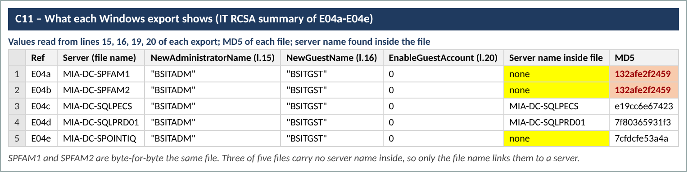
Screenshot 1 – C11_S2_export_summary.png (Evidence/Screenshots)
3. Population and sample
No population yet. The 10 servers came with the evidence; they were not picked by us from a population, which the RCSA procedure expects. Last year's CMDB shows six of them as 'Pending Install' in 2025 (E10 rows 14, 24, 25, 33, 34, 45), so they likely went to Installed in this period, but we need the dates.
Once the population is in, we will set the sample with the RCSA calculator (likely 25-45 for a High-risk, in-every-operation control) and keep these 10 if they are in it.
Result: Not evidenced – waiting for population.
Reference: E10; Testing Procedure 4.4.2
4. Control execution (per sample)
Windows (5): the built-in Administrator is renamed to BSITADM and Guest is renamed to BSITGST and disabled on all five (E04a-e lines 15, 16, 20). Neither the password change nor its date shows in a secedit export.
Linux (5): all five show PermitRootLogin no (E05). That blocks root over SSH, but the Linux guide moved this rule out of scope (E03 p.31) and the in-scope rule is root password set, SHA512 (E03 p.18). We have nothing for that rule or for when the password was set.
Result: Rename: Pass 5/5. Password changed before Installed: not evidenced 0/10.
Reference: E04a-e; E05; E03 p.18, p.31
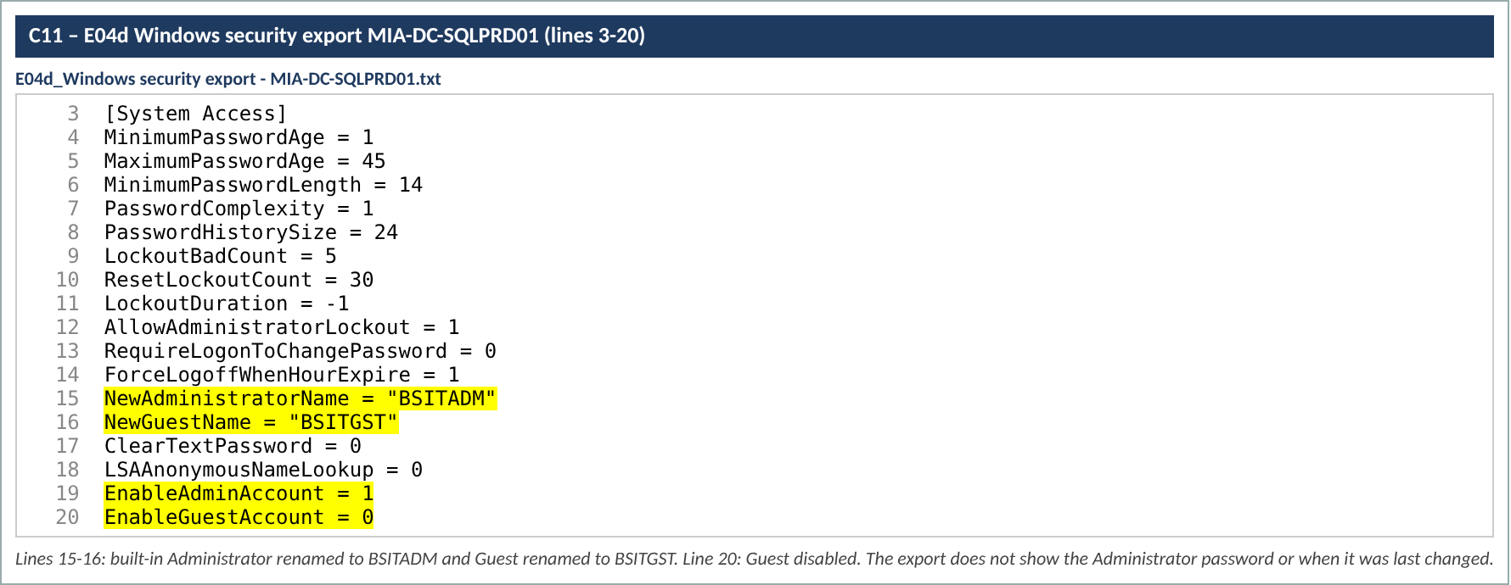
Screenshot 2 – C11_S1_SQLPRD01_export.png (Evidence/Screenshots)
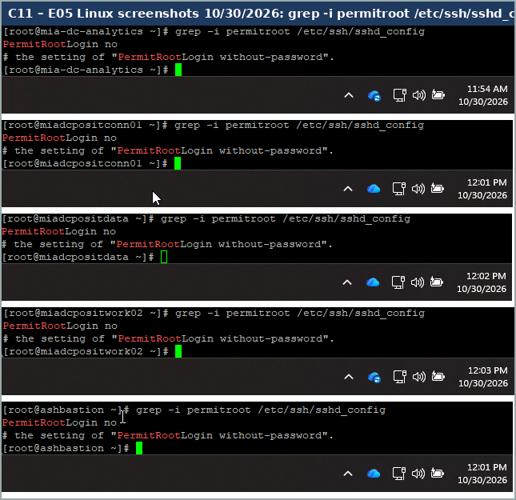
Screenshot 3 – C11_S3_Linux_PermitRootLogin.png (Evidence/Screenshots)
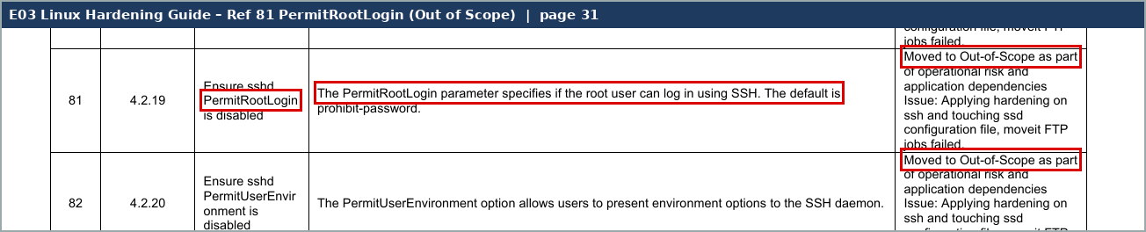
Screenshot 4 – C11_S7_Linux_PermitRootLogin_OOS.png (Evidence/Screenshots)
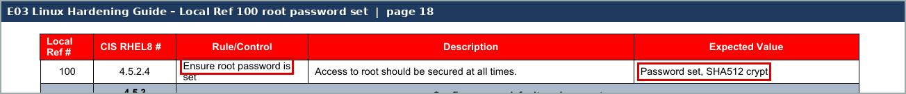
Screenshot 5 – C11_S6_Linux_root_password.png (Evidence/Screenshots)
5. Results against the Standard
SUS.SBS.4.2.3.4 is met for the default account names on Windows. Whether default passwords were changed before go-live cannot be confirmed yet for any of the 10 servers.
Result: Pending.
Reference: E01 p.12
6. Exception handling
No SEF exceptions were approved for vendor defaults in the period (E06 is empty), and none was needed for the samples.
Result: Pass – none needed.
Reference: E06
7. Escalation and remediation
No deviation found so far, so nothing to escalate.
Result: N/A for now.
8. Risk mitigation
The account renames and the root SSH block lower the risk, but the control is about default passwords before go-live. We can't conclude until the password evidence comes in.
Result: Pending.
9. Coverage and conclusion
Tested 10 servers (5 Windows, 5 Linux) for the attributes we could. The CPA is not concluded. If the open items below are not received by the due date, attributes A2 and A3 count as not evidenced and the control would be rated Weak (one exception in the original sample of an in-every-operation control allows a second sample; two fail it – Testing Procedure 4.4.8.2).
Result: Not concluded – open items OI-1 to OI-5.
Sample results
# | Server | OS | A1 Default admin / root account handled | A2 Default password changed | A3 Before CMDB Installed | Evidence | Result
1 | MIA-DC-SPFAM1 | Windows | Renamed BSITADM; Guest BSITGST disabled | Not evidenced | Not evidenced (E10 r.33 Pending Install 2025) | E04a l.15-20 | Pending
2 | MIA-DC-SPFAM2 | Windows | Same – file identical to SPFAM1 | Not evidenced | Not evidenced (E10 r.24) | E04b | Pending
3 | MIA-DC-SQLPECS | Windows | Renamed BSITADM; Guest BSITGST disabled | Not evidenced | Not evidenced | E04c l.15-20 | Pending
4 | MIA-DC-SQLPRD01 | Windows | Renamed BSITADM; Guest BSITGST disabled | Not evidenced | Not evidenced (E10 r.25) | E04d l.15-20 | Pending
5 | MIA-DC-SPOINTIQ | Windows | Renamed BSITADM; Guest BSITGST disabled | Not evidenced | E10 r.26 shows it Installed already in 2025 – may be outside the period | E04e l.15-20 | Pending
6 | mia-dc-analytics | Linux | PermitRootLogin no (out-of-scope rule) | Not evidenced | Not evidenced | E05 | Pending
7 | miadcpositconn01 | Linux | PermitRootLogin no | Not evidenced | Not evidenced (E10 r.14) | E05 | Pending
8 | miadcpositdata | Linux | PermitRootLogin no | Not evidenced | Not evidenced (E10 r.34) | E05 | Pending
9 | miadcpositwork02 | Linux | PermitRootLogin no | Not evidenced | Not evidenced (E10 r.45) | E05 | Pending
10 | ashbastion | Linux | PermitRootLogin no | Not evidenced | Not evidenced | E05 | Pending

Open items – what we need to finish
# | What we need | For | What it clears
OI-1 | CMDB report of all Windows and Linux servers that moved to Installed between 07/01/2025 and 06/30/2026, with install date, OS and the query used. | Population (step 3) | Lets us pick the sample and check timing.
OI-2 | For each Windows sample: proof the local Administrator (BSITADM) password was changed at build and its date – e.g. LAPS or CyberArk record, or 'net user BSITADM' showing Password last set. | A2, A3 | Clears A2/A3 for Windows.
OI-3 | For each Linux sample: 'chage -l root' and 'passwd -S root' (password set, SHA512, last change date) with hostname and date on screen. | A2, A3 (guide Ref 100) | Clears A2/A3 for Linux.
OI-4 | New secedit exports for MIA-DC-SPFAM1, SPFAM2 and SPOINTIQ with 'hostname' and date in the same file or screenshot. | Step 2 | Confirms the exports belong to the servers.
OI-5 | Walkthrough with Ian Rojo (or delegate) to confirm the 2026 process and who checks the password before the CMDB status changes. | CDA | Completes the CDA walkthrough.

Sampling rationale
- Population: servers that reached Installed in CMDB between 07/01/2025 and 06/30/2026 – not yet provided (OI-1).
- Method: judgmental / calculator-based once the population is known. Ten servers tested so far (5 Windows, 5 Linux), all provided with the evidence.
- 2025 for comparison: 29 samples in Cycle 1 (10 Windows, 5 Linux, 3 Oracle, 11 SQL) out of a planned 45 for the year. Oracle and SQL now belong to C10.
- Sample sizes: the control runs in every operation (each server build), mitigates a High inherent risk and is Hybrid, so medium assurance applies. For as-needed populations the RCSA sample size calculator prorates the sample on the population (RCSA Testing Procedure 4.4.2, Appendix H). Reference points from the minimum table: 151-250 items = 30, over 250 = 45. If the population is smaller than the sample, test all of it.
- A key attribute that fails fails the sample. For this frequency one exception in the original sample can be followed by an additional sample (Testing Procedure 4.4.8.2 table).

